Spectral Core Reserve Cell
White Paper Proof of Concept for a Layered Reserve Pulse Cell and Overcharge-Hold Module
Document Type | Non-operational reserve-cell and overcharge-hold proof-of-concept white paper
Concept Thesis | Use a tungsten-centered layered cell with high-conductivity housing and a safer dynamic conductive medium to create a pulse-capable reserve module that can absorb, hold, and release overcharge for emergency systems.
Primary Use | Overcharge holding, reserve pulse discharge, thermal buffering, and emergency support for critical systems
Status | High-level concept architecture draft
Abstract
Spectral Core Reserve Cell is a layered energy-module concept built around a dense tungsten core, a dynamic conductive intermediate layer, a high-conductivity silver housing, and an outer protective shell. The concept is strongest when framed not as a conventional high-capacity consumer battery, but as a specialized reserve pulse cell or overcharge-hold module designed to tolerate transient load, absorb temporary excess energy, and release that stored reserve into emergency systems when required. The original sketch used mercury as the dynamic conductive layer. This proof of concept replaces that role with a safer conductive gel, slurry, or gallium-based liquid-metal surrogate to preserve the architectural logic without inheriting mercury's major containment and toxicity problems.
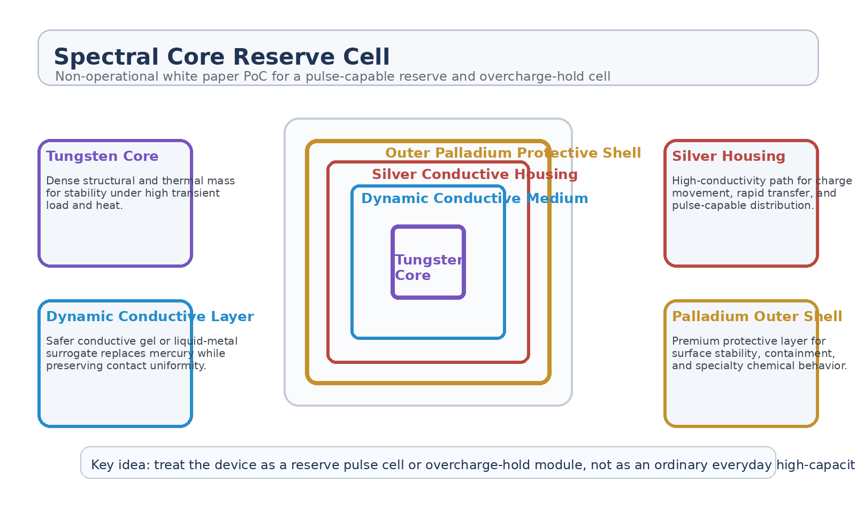
Figure 1. Spectral Core Reserve Cell with tungsten core, dynamic conductive medium, silver housing, and outer protective shell.
1. Concept Thesis
The central claim is modest and much stronger for it: this layered device is more believable as a reserve or overcharge-handling module than as an ordinary daily-use high-capacity battery. The tungsten core provides thermal and structural stability, the conductive housing moves charge efficiently, the dynamic intermediate layer improves contact and transient behavior, and the outer shell protects the whole assembly. Together they form a cell designed for stress tolerance, pulse service, and emergency reserve behavior.
This makes the concept suitable for backup systems, staged discharge, and high-stress energy handling rather than routine main-bus storage.
2. Why the Original Layering Logic Is Interesting
• Tungsten supports high thermal tolerance and internal structural density.
• Silver provides an excellent conductive path for rapid charge transfer.
• A dynamic conductive layer can improve interface behavior under load.
• An outer specialty shell can add containment, durability, and chemistry-specific protection.
The weakness in the original sketch is not the layered logic itself. It is the choice of mercury as the mobile conductive layer. Replacing that layer with a safer medium preserves the architectural intent while making the concept less self-defeating.
3. Recommended Material Reframe
To preserve the conceptual behavior while improving safety, the dynamic conductive layer should be treated as a design class rather than one fixed material. Suitable stand-ins at the PoC level include conductive gels, sealed slurries, ionic media, or a safer liquid-metal family such as a gallium-based system. The goal is not to lock the concept to one chemistry, but to preserve the function: transient smoothing, interface uniformity, and overcharge capture support.
• Replace mercury with a safer conductive gel, slurry, or gallium-based liquid-metal surrogate.
• Keep tungsten as the thermal and structural anchor.
• Keep silver as the fast conductive housing layer.
• Treat the outer shell as a protective containment and specialty interface layer.
4. System Architecture
Layer | Subsystem | Primary Function | Role
L1 | Tungsten Core | Provide dense internal structure and thermal buffering. | Stability anchor
L2 | Dynamic Conductive Medium | Smooth interfaces, support transient charge behavior, and improve load tolerance. | Adaptive inner layer
L3 | Silver Housing | Move charge rapidly and distribute pulse-capable current. | Fast conductive shell
L4 | Protective Outer Shell | Contain, shield, and stabilize the overall module. | Containment layer
L5 | Emergency Output Interface | Route held reserve into backup systems when commanded. | Reserve release point

4.1 Overcharge Hold Role
This device is most coherent when treated as an overcharge-hold cell. During short periods of excess available energy, the cell absorbs and stabilizes that charge instead of allowing it to dissipate or over-stress more delicate storage layers. Later, the reserve can be discharged into emergency circuits, pulse-demand systems, or critical survivability loads.
4.2 Reserve Pulse Role
The layered architecture also makes sense as a pulse-capable reserve module. Instead of providing the ship's entire ordinary energy budget, it exists to answer high-stress moments: startup surges, backup system continuity, emergency lighting, fault bridging, or short controlled discharges into protected loads.
5. Best Mission Roles
• Emergency reserve cell for critical systems.
• Overcharge sink for transient energy spikes.
• Pulse-capable backup module for staged release.
• Thermal-buffered reserve for degraded or damaged power networks.
• Specialized support cell inside a larger continuity-power architecture.
6. Why This Is Stronger Than Calling It a Normal Battery
• It explains the dense and premium materials as stress-tolerance choices rather than everyday economics.
• It gives the dynamic conductive layer a meaningful job beyond novelty.
• It fits better with emergency continuity and overcharge-hold logic.
• It avoids overselling the concept as a simple capacity-maximization trick.
• It aligns with the broader reserve and overdrive ideas already present in the surrounding architecture.
7. Boundaries and Realism
Spectral Core Reserve Cell should be framed honestly as a specialized reserve or overcharge-handling module. It is not automatically a practical mainstream battery chemistry, and it should not be sold as one. The layered concept is strongest where transient tolerance, heat handling, and emergency reserve behavior matter more than low cost, low mass, or everyday recharge convenience.
• Best understood as a reserve pulse cell or overcharge-hold module.
• Mercury is the least defensible part of the original sketch and should be replaced.
• Still limited by real electrochemical or electrothermal constraints.
• Most believable as part of a larger backup-power system rather than as the sole energy source.
8. Proof-of-Concept Build Path
Phase | Goal | Bench / Program Activity | Success Signal
P1 | Layered mockup baseline | Construct a non-hazardous layered surrogate and characterize thermal and structural behavior. | Stable layered package
P2 | Dynamic medium study | Compare gel, slurry, or safer liquid-metal surrogate behavior in the intermediate layer. | Usable interface behavior
P3 | Pulse handling review | Evaluate whether the cell surrogate tolerates short reserve-discharge events cleanly. | Cleaner pulse response
P4 | Overcharge hold test | Route temporary excess energy into the module and observe retained reserve behavior. | Measured reserve retention
P5 | System integration | Connect the module to a simulated emergency backup bus. | Coherent reserve-module role

9. Conclusion
Spectral Core Reserve Cell is strongest when interpreted as a reserve architecture, not a miracle battery. The tungsten core stabilizes. The dynamic conductive layer adapts. The silver housing moves charge quickly. The outer shell protects. Together they create a module that is well suited to holding overcharge, tolerating stress, and supporting backup systems when normal power logic is under strain.
As a white paper PoC, the concept works best as a pulse-capable reserve cell behind the main system: not the whole power plant, but the thing that keeps the lights on when the rest of the stack is hurting.
Working one-line doctrine: Keep the tungsten core and layered conductive-shell logic, replace mercury with a safer dynamic medium, and frame the device as an overcharge-hold reserve cell rather than a standard battery.

